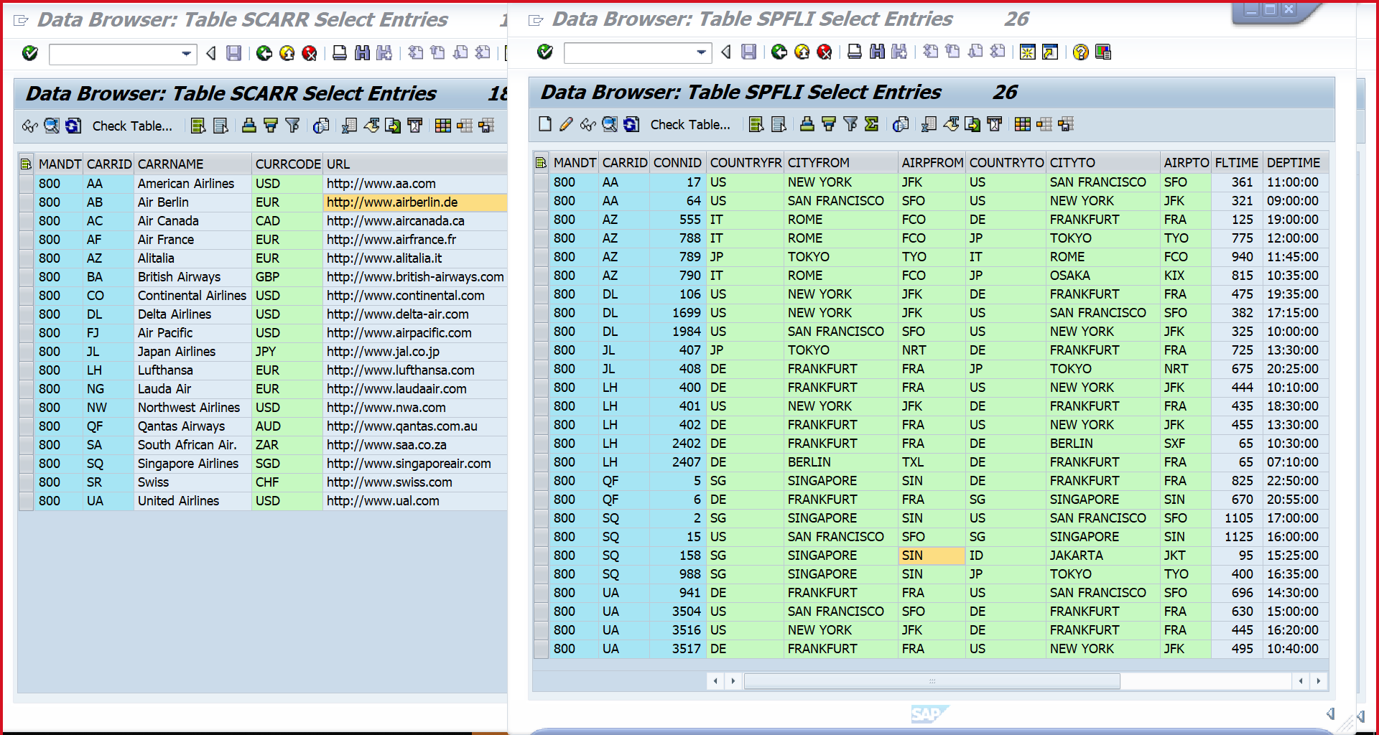

The below relationship is seen in SFLIGHT table.

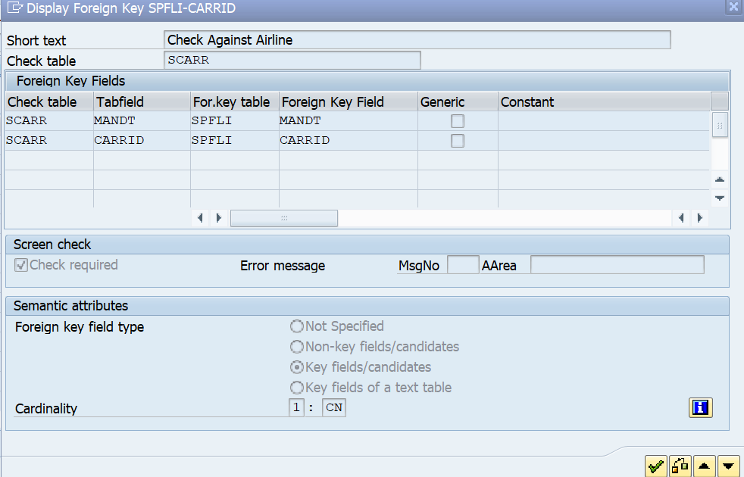

REPORT Z NO STANDARD PAGE HEADING.

TYPES: BEGIN OF TYAIRLINES,

SCCARRID TYPE SCARR-CARRID,

CARRNAME TYPE SCARR-CARRNAME,

SPCARRID TYPE SPFLI-CARRID,

CONNID TYPE SPFLI-CONNID,

COUNTRYFROM TYPE SPFLI-COUNTRYFR,

COUNTRYTO TYPE SPFLI-COUNTRYTO,

END OF TYAIRLINES.

DATA ITAIRLINES TYPE STANDARD TABLE OF TYAIRLINES.

DATA WAAIRLINES LIKE LINE OF ITAIRLINES.

SELECT SC~CARRID SC~CARRNAME

SP~CARRID SP~CONNID SP~COUNTRYFR SP~COUNTRYTO

INTO TABLE ITAIRLINES

FROM SCARR AS SC

LEFT OUTER JOIN

SPFLI AS SP

ON SC~CARRID = SP~CARRID.

LOOP AT ITAIRLINES INTO WAAIRLINES.

PERFORM DISP.

ENDLOOP.

SKIP.

FORM DISP.

WRITE : / WAAIRLINES-SCCARRID ,

9 WAAIRLINES-CARRNAME,

38 WAAIRLINES-SPCARRID ,

58 WAAIRLINES-CONNID,

68 WAAIRLINES-COUNTRYFROM,

88 WAAIRLINES-COUNTRYTO.

ENDFORM.

